**ONLINE BUS TICKET BOOKING SYSTEM**

**Software Engineering Project**

**By**

**Rasmi Jati**

**Exam Roll No: 7930/17**



**Submitted to:**

**Indra PC (Lecturer)**

**Roshan Rijal (Project Supervisor)**

**Kantipur College of Management and Information Technology**

In Partial Fulfillment of the Requirements for the Course Software Engineering

Mid Baneshwor, Kathmandu

August, 2021

**PREFACE**

*The project is about* ***“Online Bus Ticket Booking System”*** *that is developed with the intensity of helping those people who travels from one place to another by saving both time and money. The report provides the basic knowledge of database and web programming in which different technologies such as* ***JAVA, CSS, JSP, SERVLET*** *and* ***MYSQL*** *is used.*

*The whole project have been divided in four chapters.*

* *Introduction*
* *Requirements, design and system models*
* *Development and testing*
* *Conclusion*

**ACKNOWLEDGEMENT**

*Presentation, inspiration and motivation have always played a key role in the success of any venture.*

*I express my sincere thanks to our respected sir Mr. Indra PC and our project supervisior Mr. Roshan Rijal for providing their invaluable guidance, comments, supports, encouragement and suggestions in completion of my project.*

*Last, but not the least, my parents are also an important inspiration for me. So with due regards, I express my gratitude to them.*

**LIST OF TABLES**

* + - 1. *Admin Login Table*
      2. *Route Table*
      3. *Register Table*
      4. *Booking Table*

**LIST OF FIGURES**

*2.2.1 E-R diagram*

*2.3.1 Use case diagram*

*2.3.2 Sequence diagram*

*2.3.3 State diagram*

* + 1. *Login Page*

*3.1.2 Admin Login Page*

*3.1.3 Registration Page*

*3.1.4 Ticket Booking Page*

*3.2.1.1 Test for Invalid Login Data*

*3.2.1.2**Test for Valid Login Data*

*3.2.2 Viewing Ticket Detail of User*

*3.2.3 Deletion of Ticket*

*3.2.4 Update of Ticket*

*3.2.5.1 List of Registered Passengers*

*3.2.5.2 Form to Delete Account of passenger*

*3.2.5.3 Message after Deletion of Passenger’s Account*

*3.2.5.4 List of Passengers after Deletion of a passenger*

**Table of Contents**

CHAPTER I 7

INTRODUCTION 7

1.1 Existing System Introduction 7

1.2 Developed System Advantage over Existing System 7

1.3 Limitations of the Developed System 7

CHAPTER II 8

REQUIREMENTS, DESIGN AND MODELS 8

2.1 Requirements 8

2.2 Design 9

2.2.1 System Design 9

2.2.2 Relational Database Tables 10

2.3.3 System Models 11

CHAPTER 3 14

DEVELOPMENT AND TESTING 14

3.1 Development 14

3.1.1 Login Form 14

3.1.2 Admin Login Form 14

3.1.3 Registration Form 15

3.1.4 Ticket Booking Form 15

3.1 Testing the System 16

3.2.1 Test for User Login 16

3.2.2 View Ticket Details 18

3.2.3 Deletion of Ticket 18

3.2.4 Update of Ticket 20

3.2.5 Account Deletion of Passenger 21

CHAPTER 4 23

CONCLUSION 23

# CHAPTER I

# INTRODUCTION

This Online Bus Ticket Booking System is developed in Java as a web-based project. This project is developed for those people who wants to travel and explore new places. People have to wait long hours in bus ticket counter to get the ticket for the bus so this system might be of great use for those people as they can book the tickets online easily. The purpose of developing this system is to easily book ticket without having to go to the bus counter for the ticket.

## 1.1 Existing System Introduction

*The existing system of bus ticket booking is time-consuming for both bus ticket booking company and passengers. Ticket booking do not support for long time period. Accessing and updating the system is slow. And overall, the system is not web-based but is file-based processing.*

## 1.2 Developed System Advantage over Existing System

The developed system is a web based system that allows online bus ticket booking.

**Advantages:**

* *Easy to use*
* *Time saving*
* *Accessing and updating is fast*
* *Ticket booking support up to 1 year*

## 1.3 Limitations of the Developed System

The following are the limitation of this system.

* *Form validation is not done properly.*
* *Seat choosing facility is not available.*

# CHAPTER II

# REQUIREMENTS, DESIGN AND MODELS

## 2.1 Requirements

The following points describes what this system can do.

**Functional Requirement:**

* *Booking and cancellation of the bus tickets.*
* *Update and view of the tickets.*
* *Maintain the passenger’s ticket booked records and the passenger’s personal records.*
* *Booking tickets is less time consuming.*
* *Free registration for customers.*
* *User and Admin Login*

**Non-functional Requirement:**

* *Efficient*
* *Dependable*
* *Ease of use*

## 2.2 Design

### 2.2.1 System Design

Customer

has to

Register

Login

for

Booking

**Figure 2.2.1: E-R diagram**

### 2.2.2 Relational Database Tables

|  |  |  |  |
| --- | --- | --- | --- |
| **S.No.** | **Field name** | **Type** | **Description** |
| *1.* | *Admin_id* | *Number* | *Store id of admin* |
| *2.* | *Email* | *Text* | *Store email of admin* |
| *3.* | *Password* | *Text* | *Store password of admin* |

**Table 2.2.2.1: Admin Login Table**

|  |  |  |  |
| --- | --- | --- | --- |
| **S.No.** | **Field name** | **Type** | **Description** |
| *1.* | *Route_id* | *Number* | *Store id of route* |
| *2.* | *Route* | *Text* | *Store name of route* |
| *3.* | *Price* | *number* | *Store total amount of particular route* |

**Table 2.2.2.2: Route Table**

|  |  |  |  |
| --- | --- | --- | --- |
| **S.No.** | **Field name** | **Type** | **Description** |
| *1.* | *User_id* | *Number* | *Store id of user* |
| *2.* | *Name* | *Text* | *Store name of user* |
| *3.* | *Address* | *Text* | *Store address of user* |
| *4.* | *Phone number* | *Number* | *Store phone number of user* |
| *5.* | *Email* | *Text* | *Store email of user* |
| *6.* | *Password* | *Text* | *Store the password* |

**Table 2.2.2.3: Register Table**

|  |  |  |  |
| --- | --- | --- | --- |
| **S.No.** | **Field name** | **Type** | **Description** |
| *1.* | *User_id* | *Number* | *Store id of user* |
| *2.* | *Name* | *Text* | *Store name of user* |
| *3.* | *Ticket_on_date* | *Date* | *Store date of ticket for travelling* |
| *4.* | *Route* | *Text* | *Store name of route* |
| *5.* | *Price* | *Number* | *Store total amount of particular route* |
| *6.* | *Number of days* | *Number* | *Store number of days* |
| *7.* | *Number of people* | *Number* | *Store number of people* |
| *8.* | *Total fare* | *Number* | *Store total price* |

**Table 2.2.2.4: Booking Table**

### 2.3.3 System Models

#### 2.3.1 Use case diagram

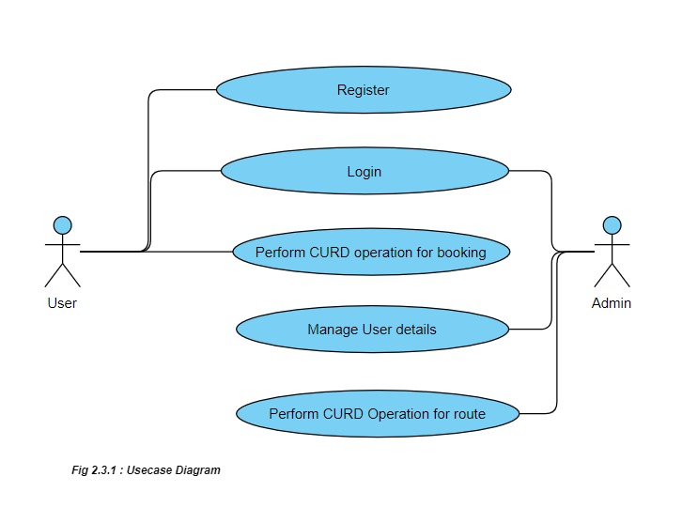

#### 2.3.2 Sequence diagram

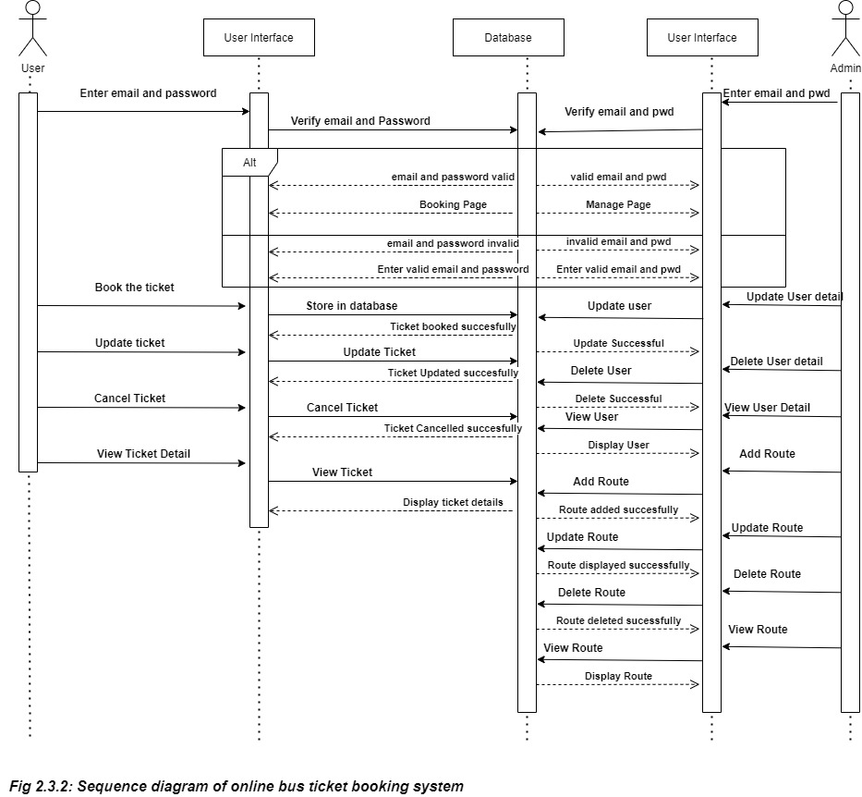

#### 2.3.3 State diagram

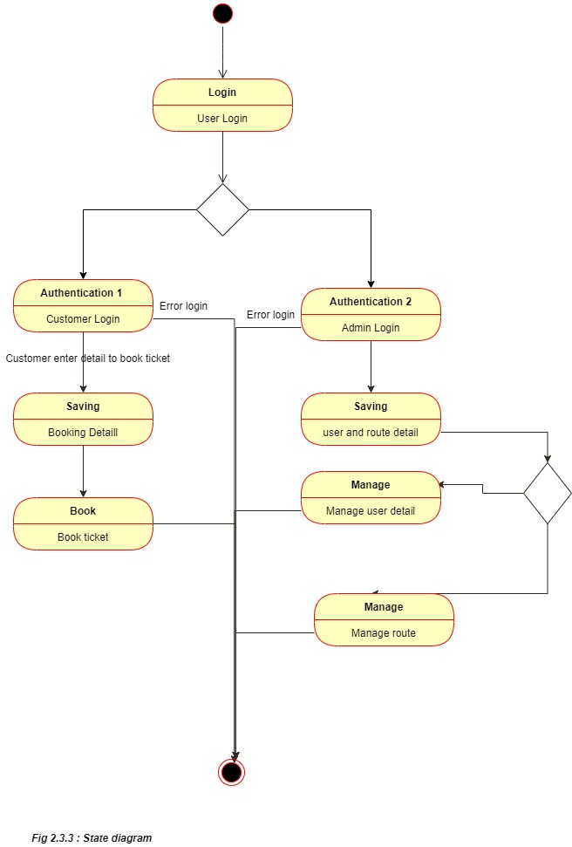

# CHAPTER 3

# DEVELOPMENT AND TESTING

## 3.1 Development

### 3.1.1 Login Form

*Login form is developed for the authorized user to do the further process. The unauthorized user are not allowed for further processes.*

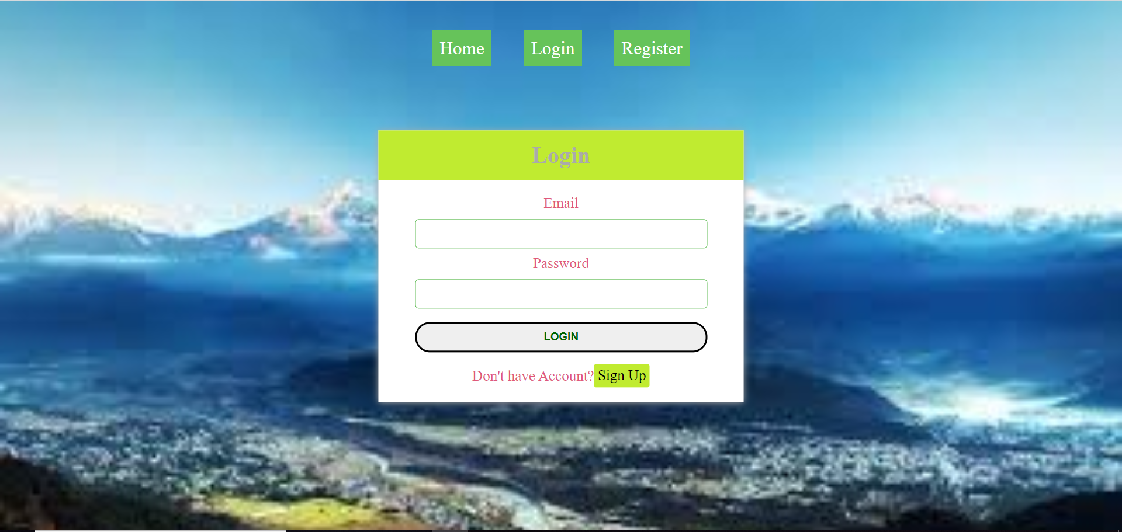

**Figure 3.1.1: Login Page**

### 3.1.2 Admin Login Form

*Admin Login form is developed for the authorized user to do the further process. The unauthorized user are not allowed for further processes.*

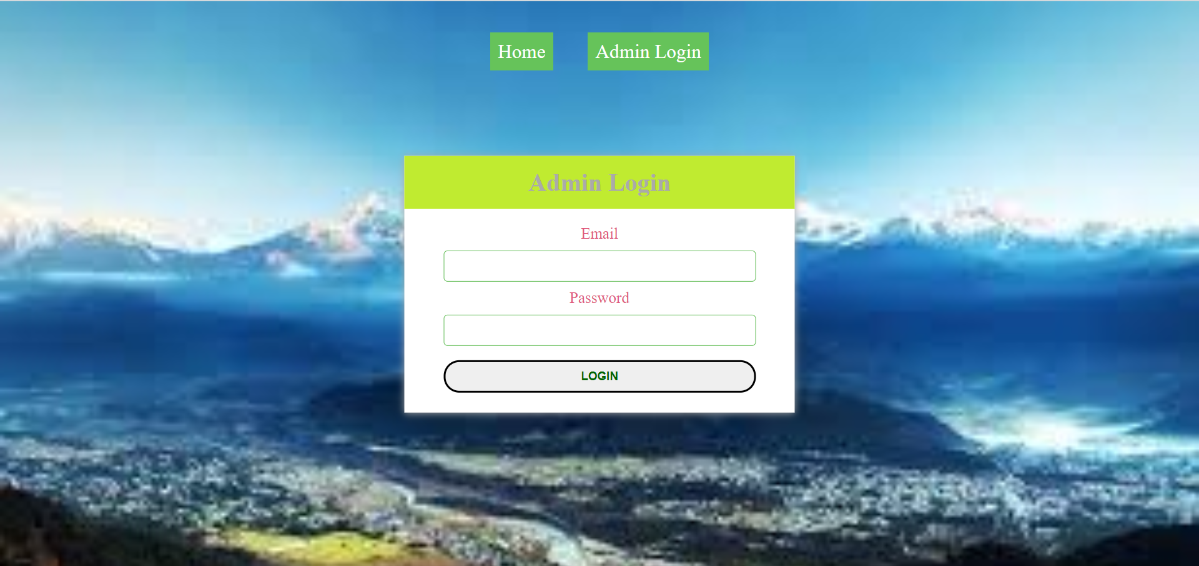

**Figure 3.1.2: Admin Login Page**

### 3.1.3 Registration Form

*Registration form is for those people who want the access to our system. The user should register to get authorized for further process.*

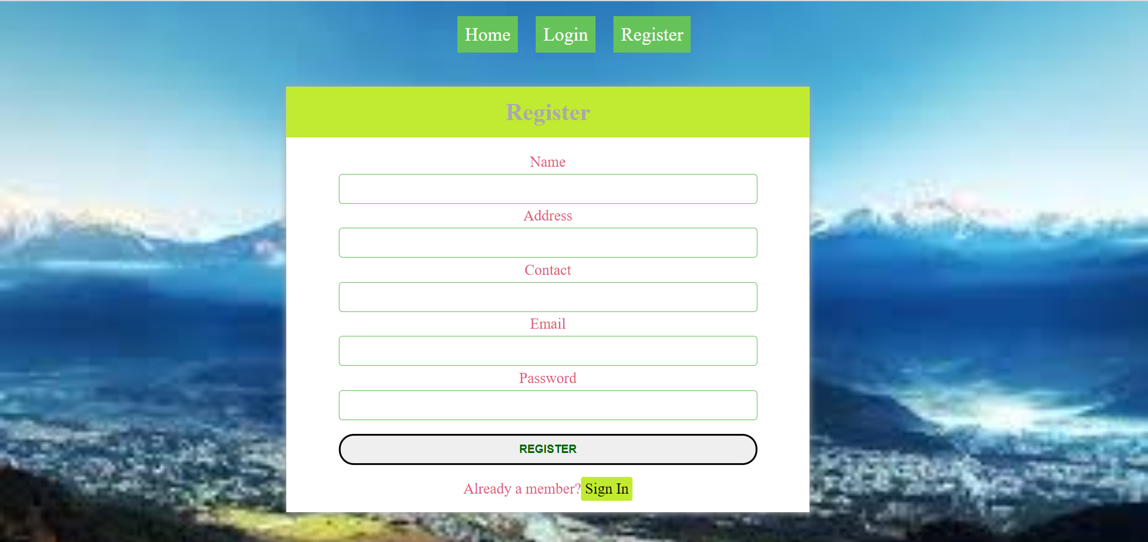

**Figure 3.1.3: Registration Page**

### 3.1.4 Ticket Booking Form

*Ticket booking form is to book the ticket by filling the required information*

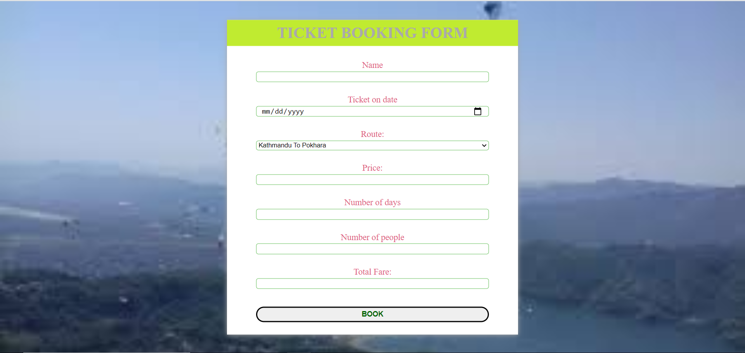

**Figure 3.1.4: Ticket Booking Page**

## Testing the System

*Testing is an improvement phase. This phase involves testing of developed system using different form of data.*

### 3.2.1 Test for User Login

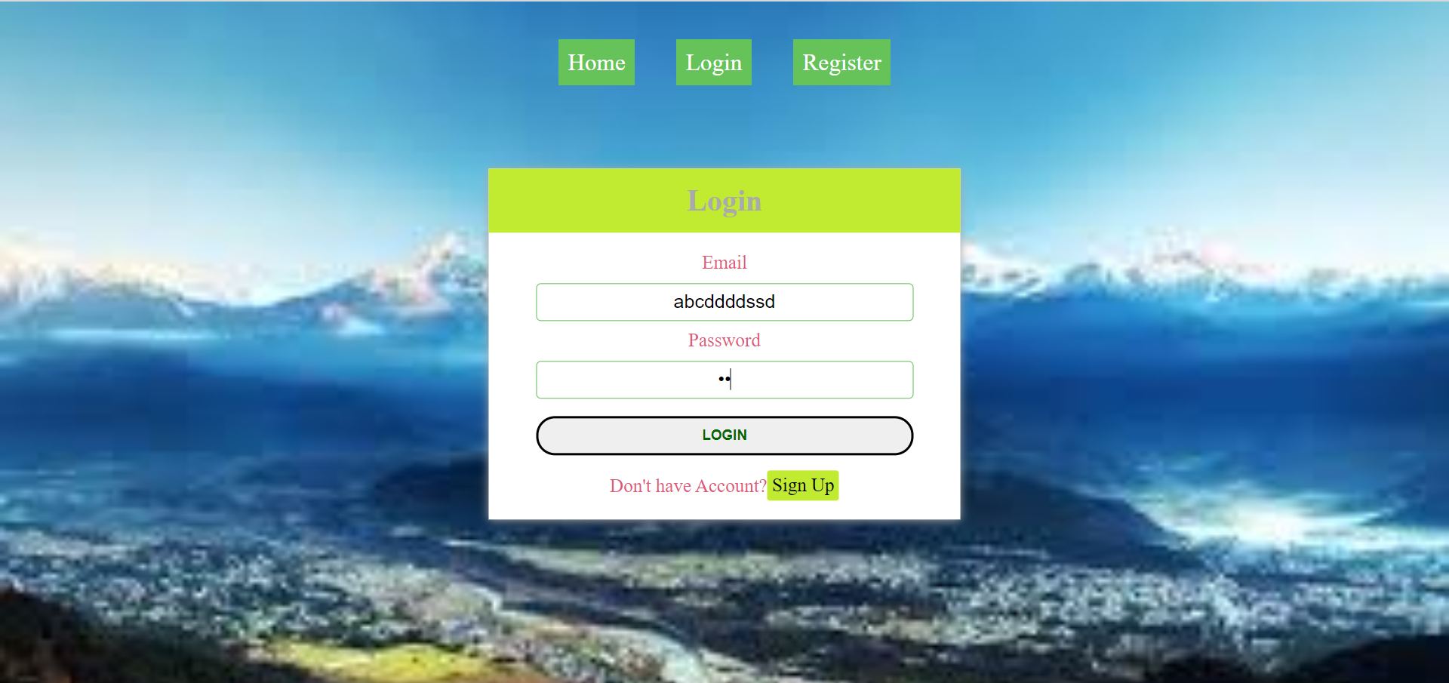

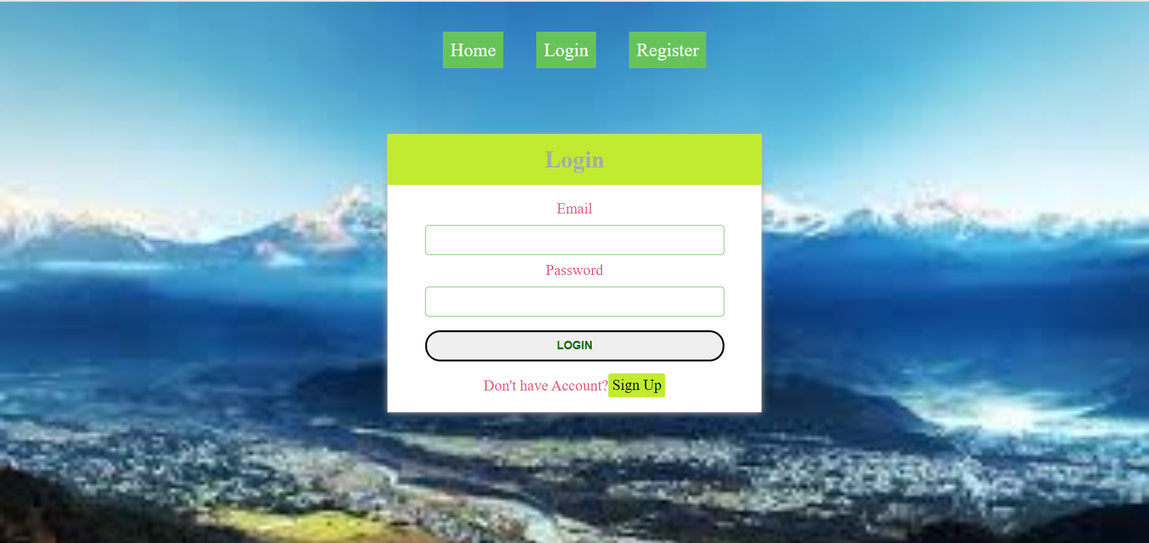

**Figure 3.2.1.1: Test for Invalid Login Data**

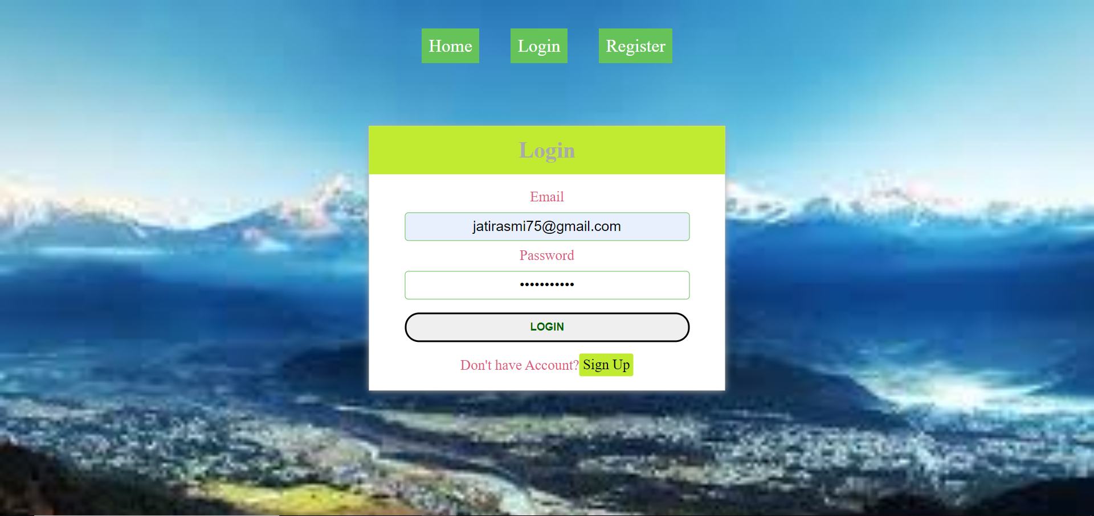 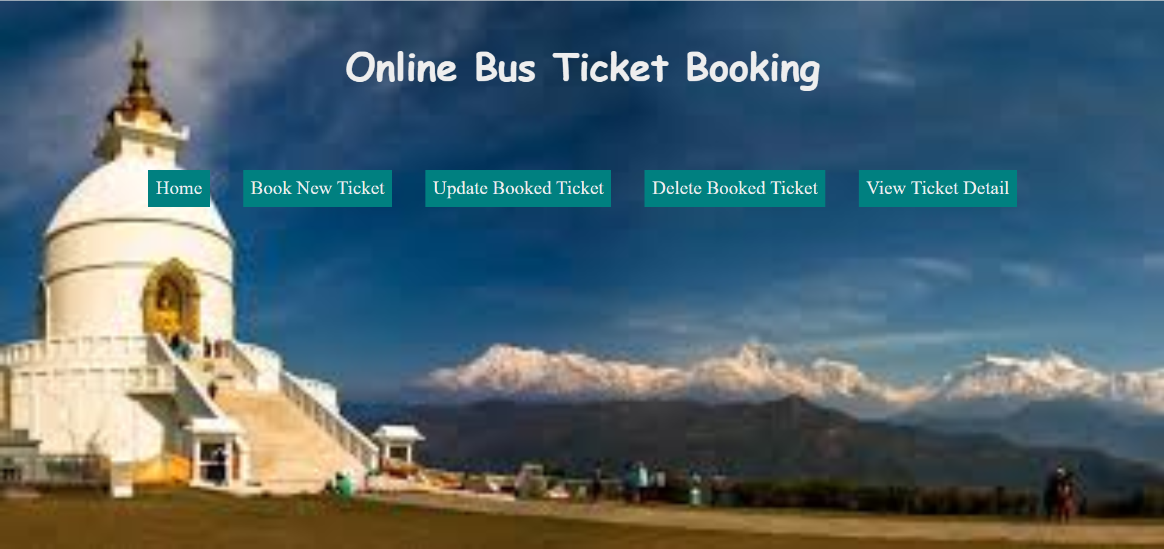

**Figure 3.2.1.2: Test for Valid Login Data**

### 3.2.2 View Ticket Details

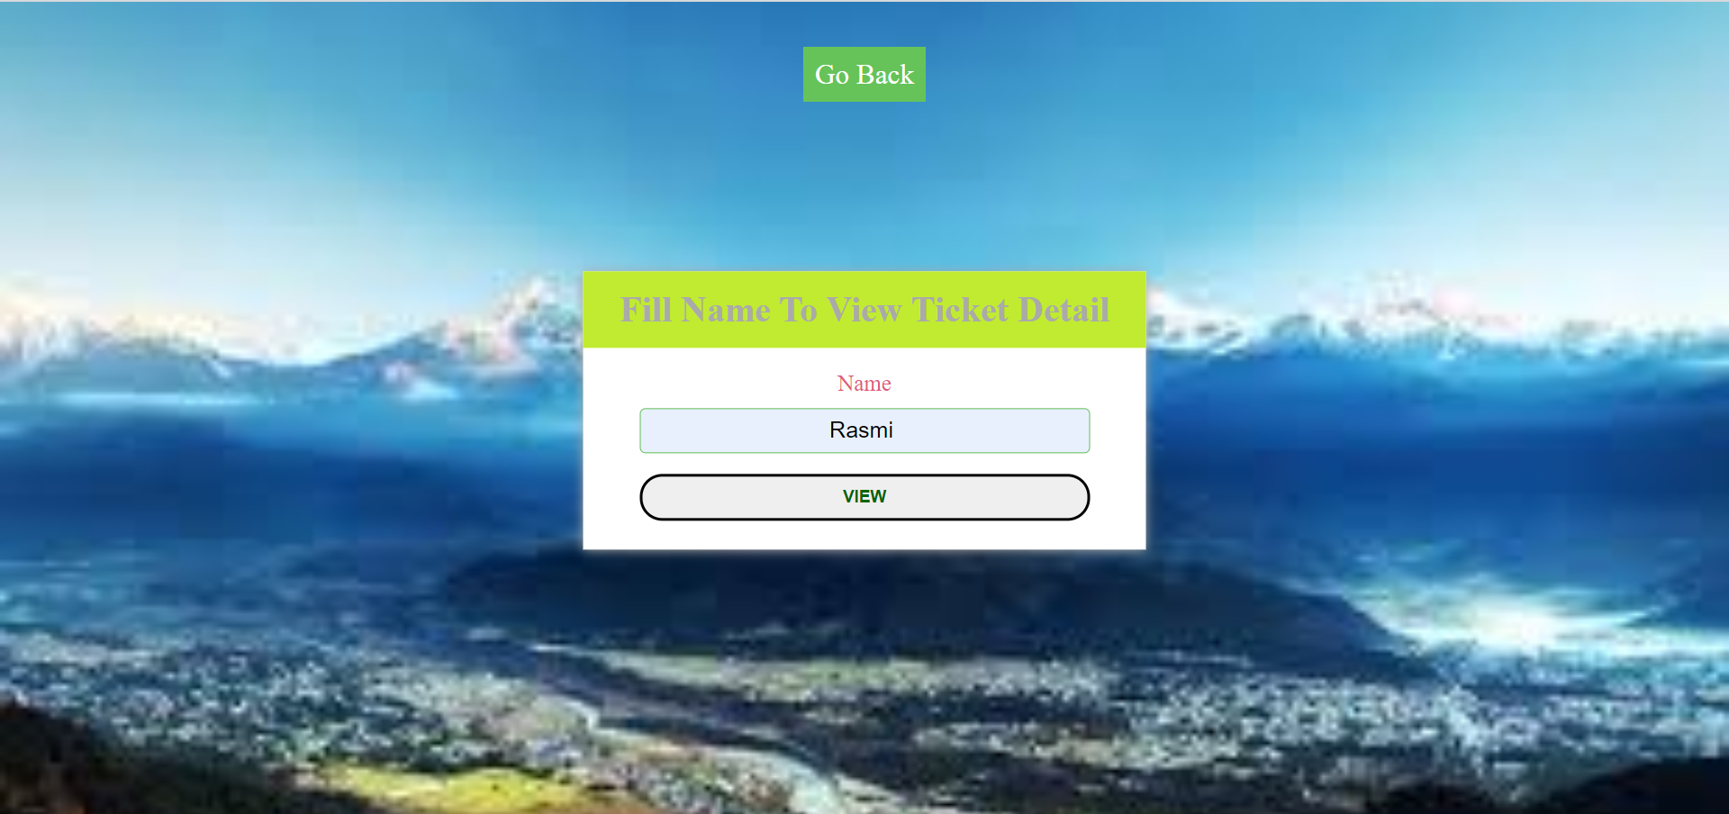

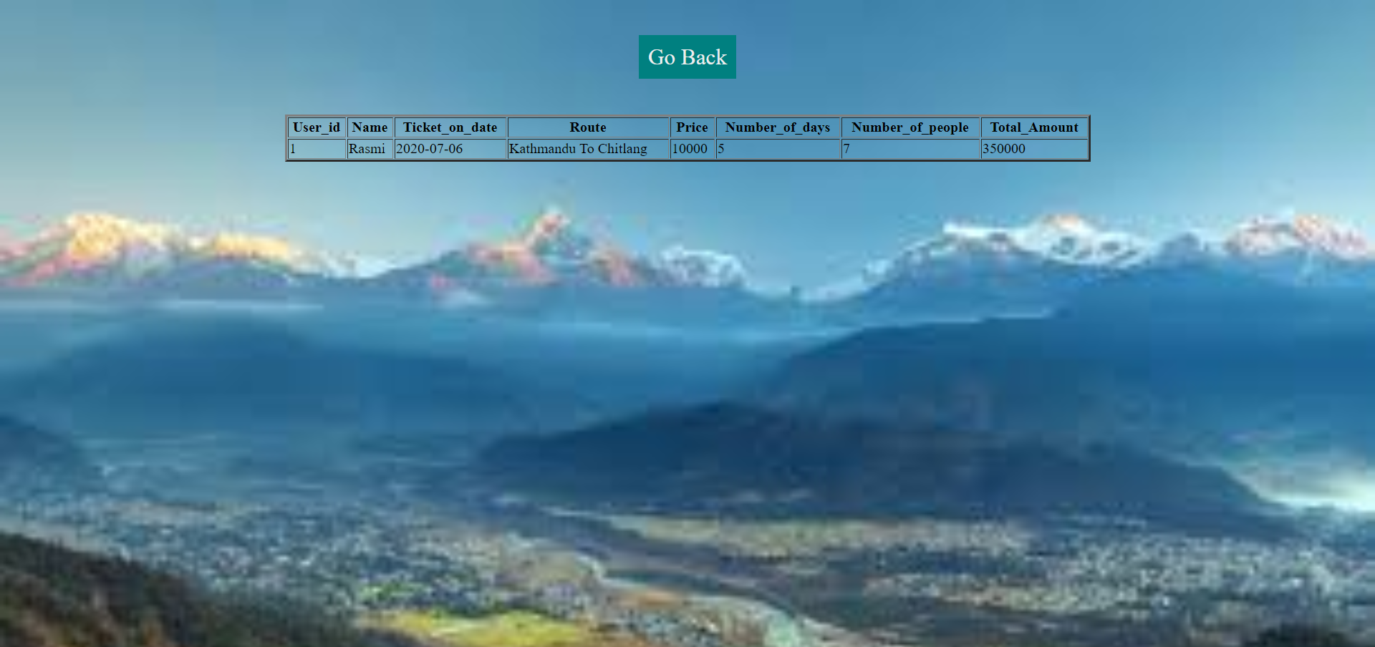

**Figure 3.2.2: Viewing Ticket Detail of User**

### 3.2.3 Deletion of Ticket

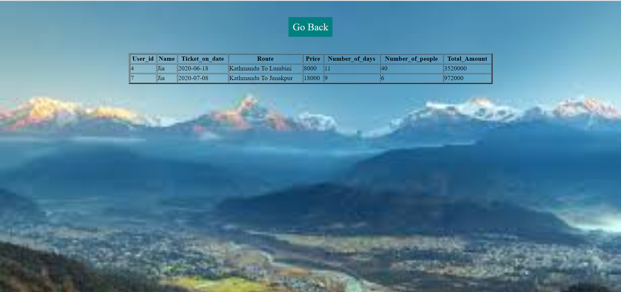

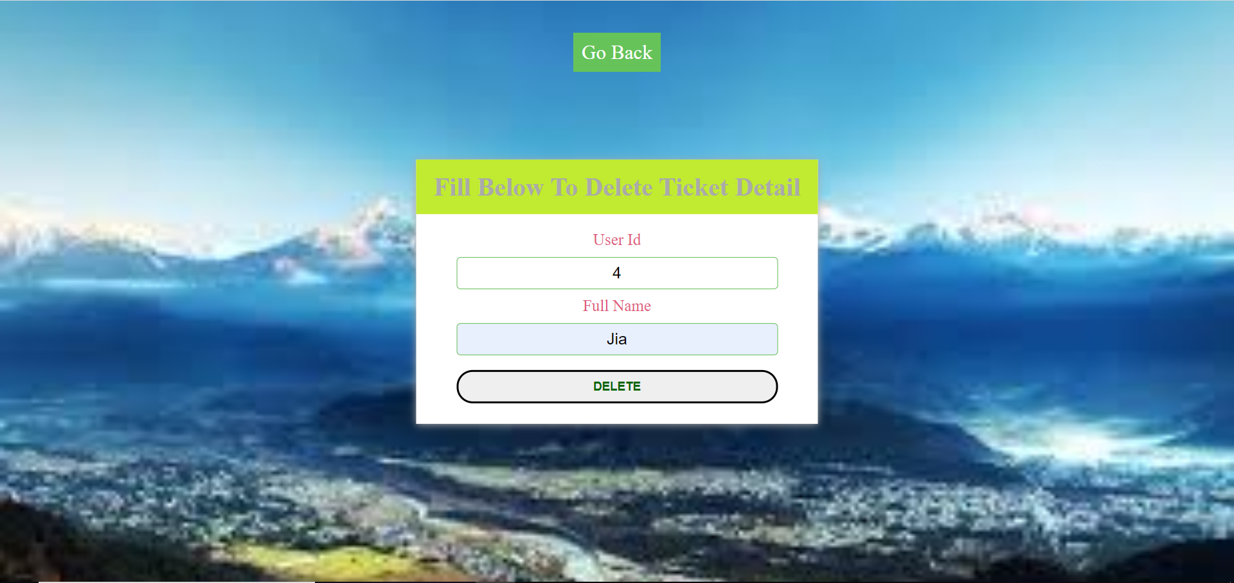

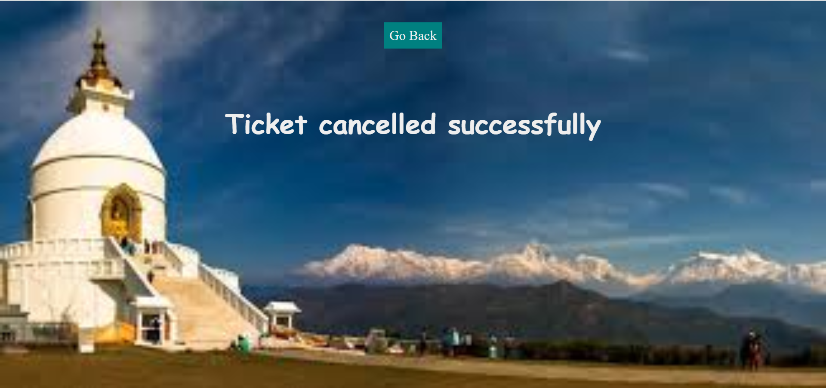

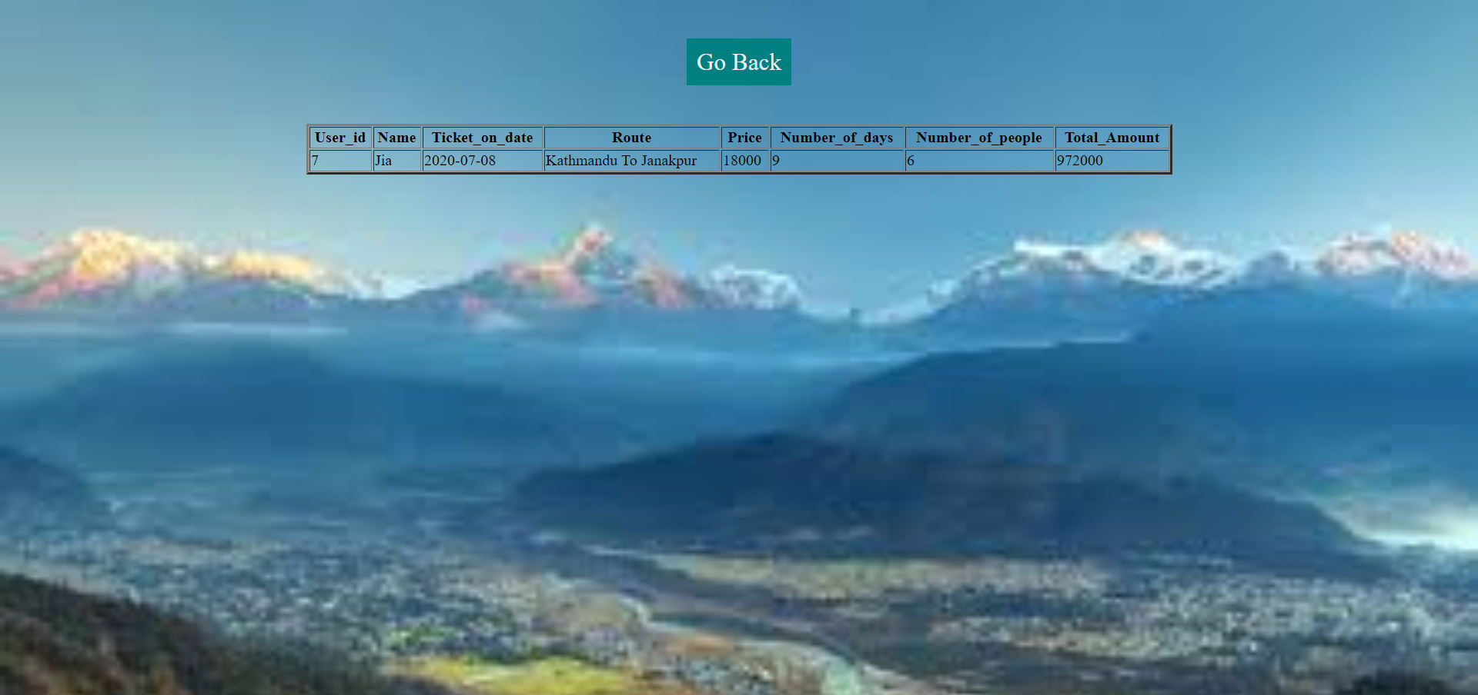

**Figure 3.2.3: Deletion of Ticket**

### 3.2.4 Update of Ticket

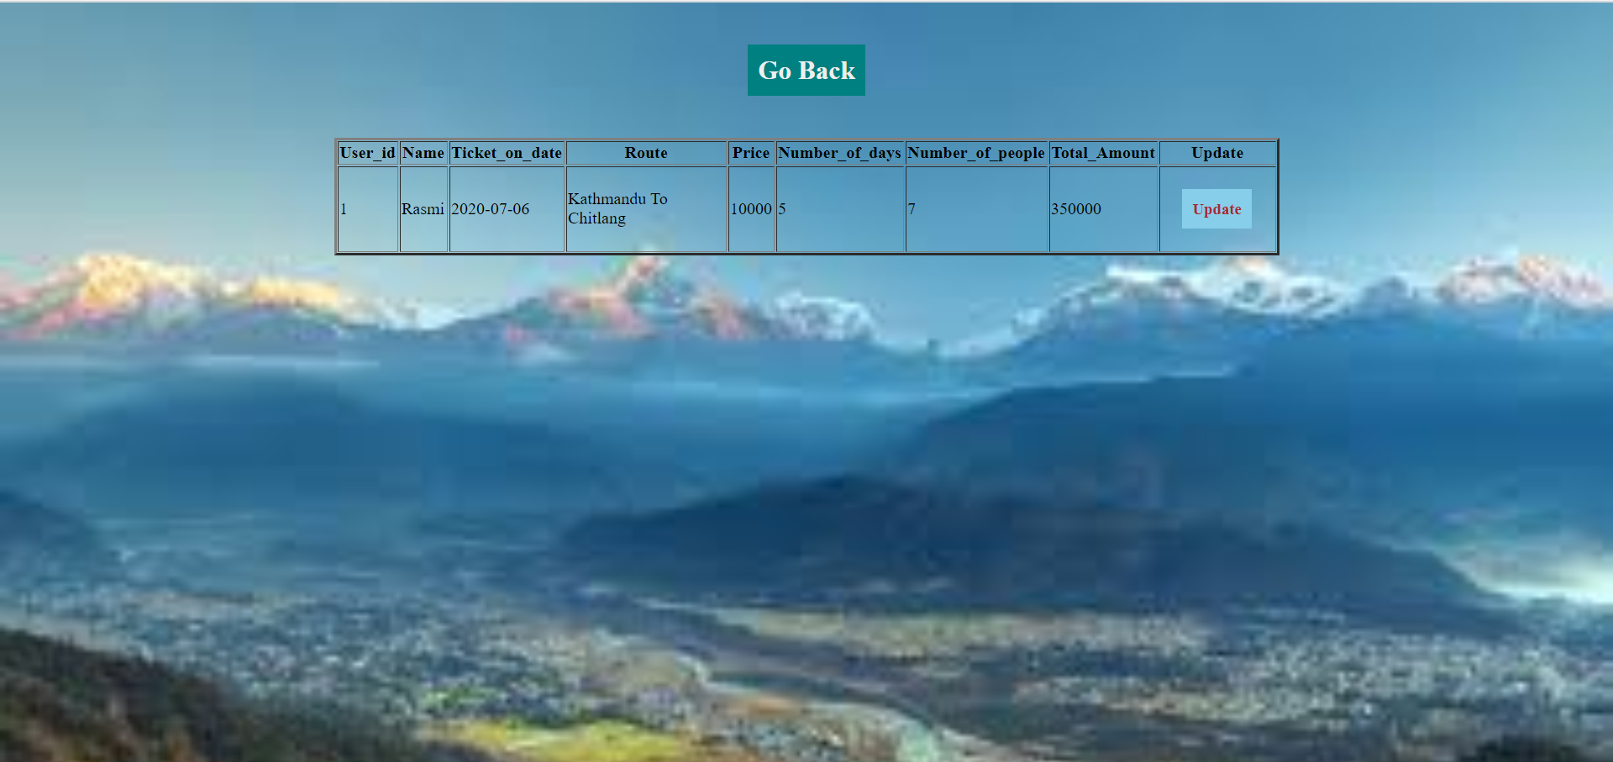

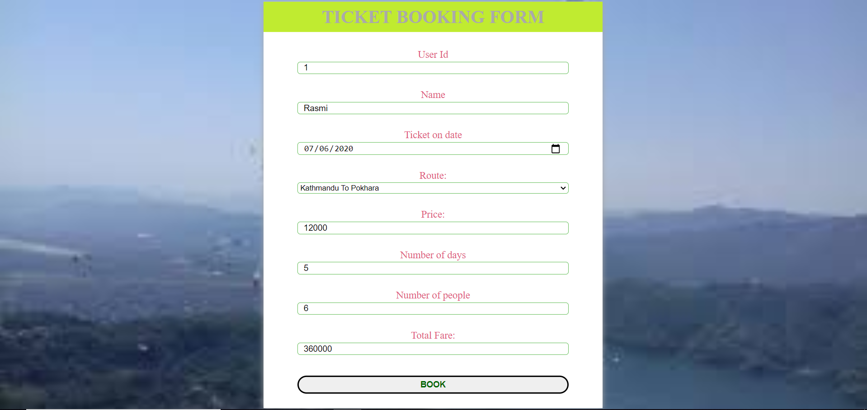

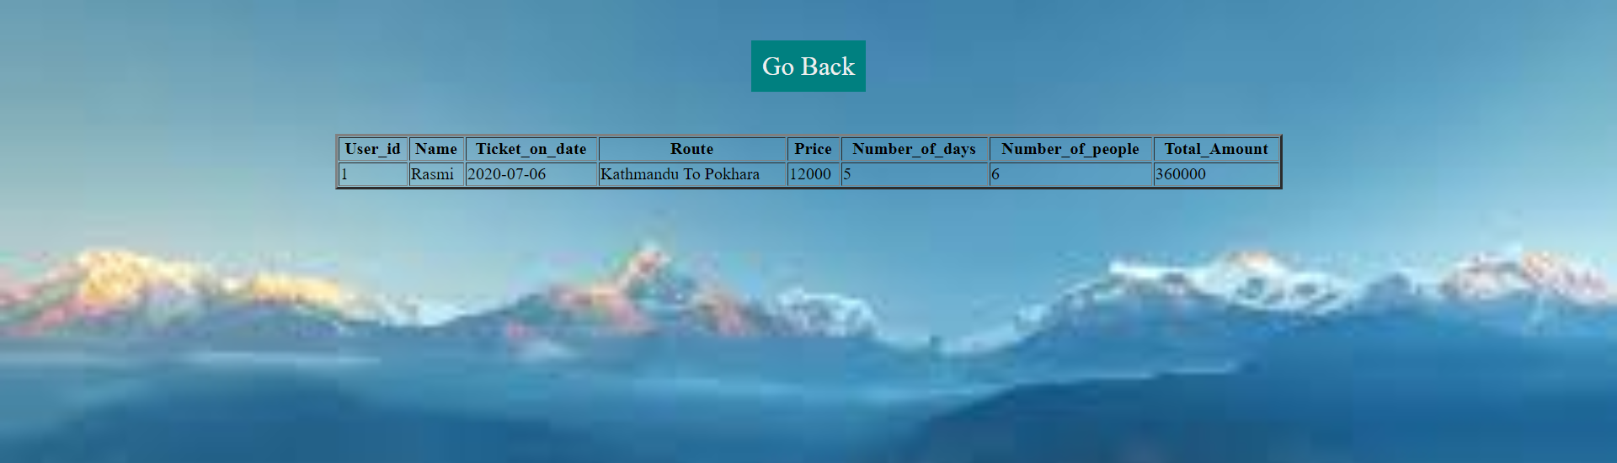

**Figure 3.2.4: Update of Ticket**

### 3.2.5 Account Deletion of Passenger

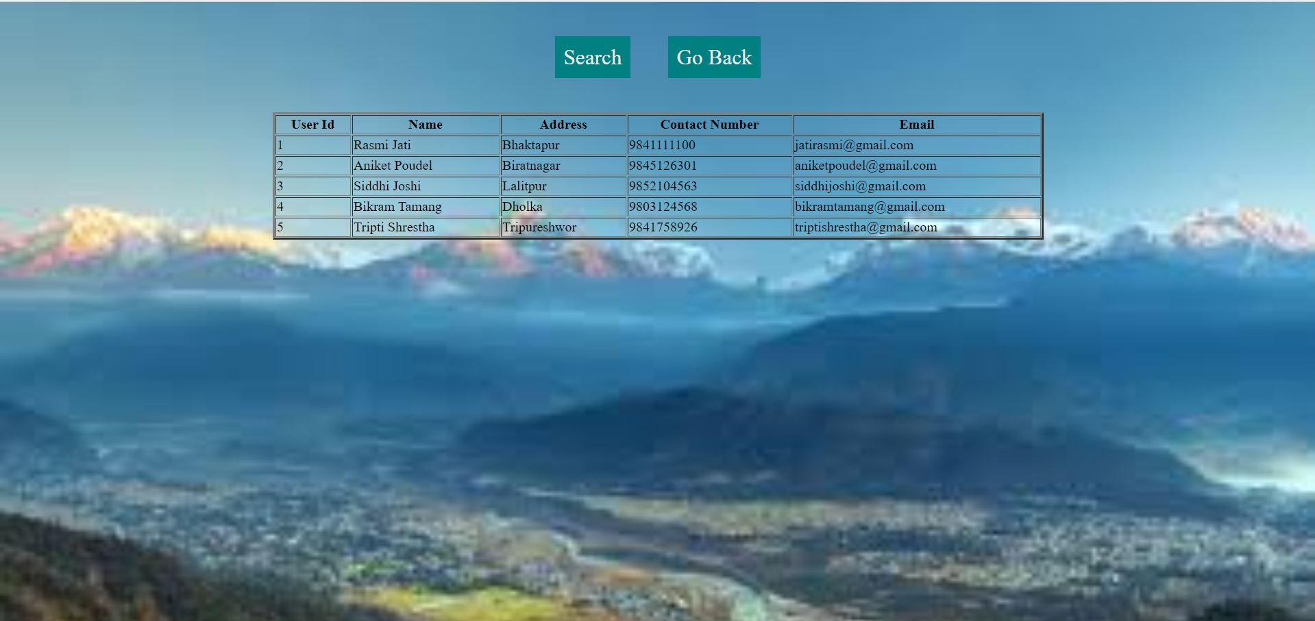

**Figure 3.2.5.1: List of Registered Passengers**

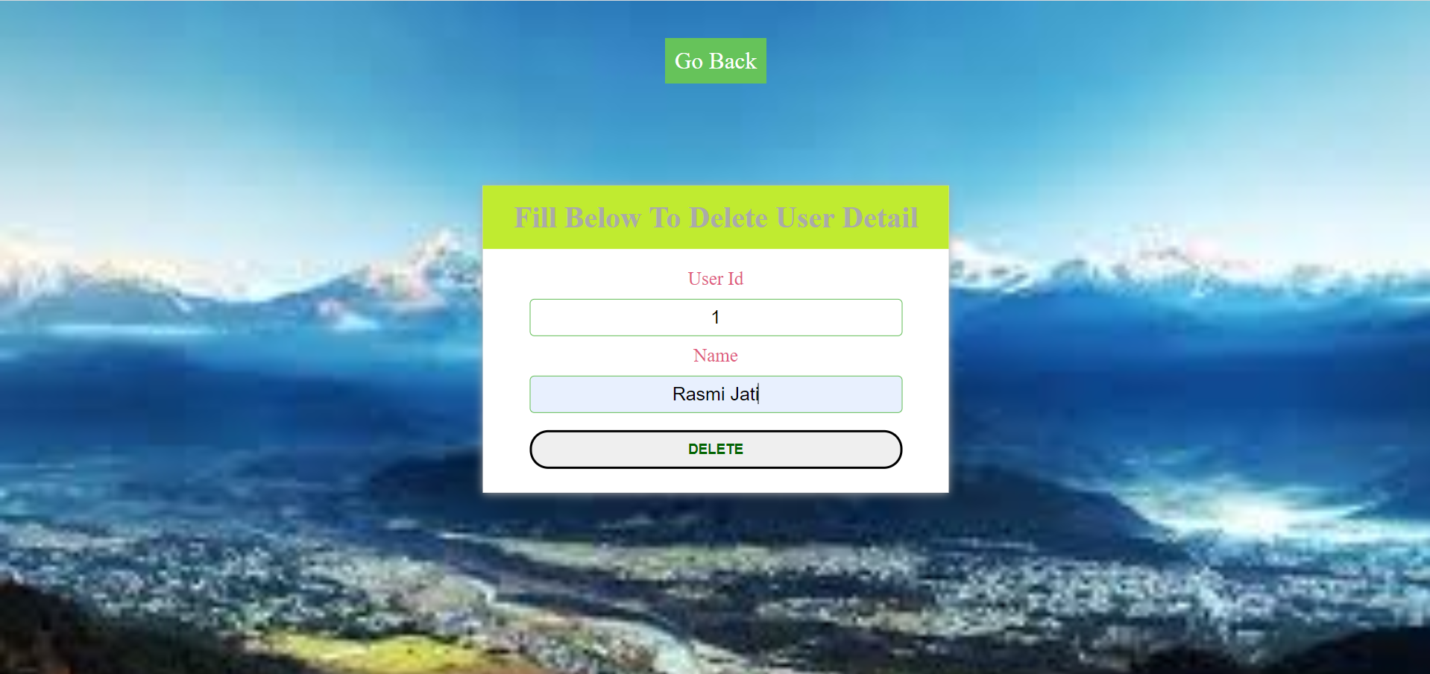

**Figure 3.2.5.2: Form to Delete Account of passenger**

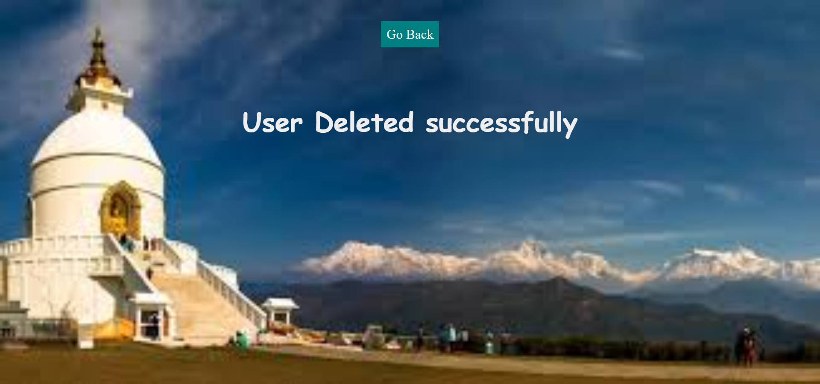

**Figure 3.2.5.3: Message after Deletion of Passenger’s Account**

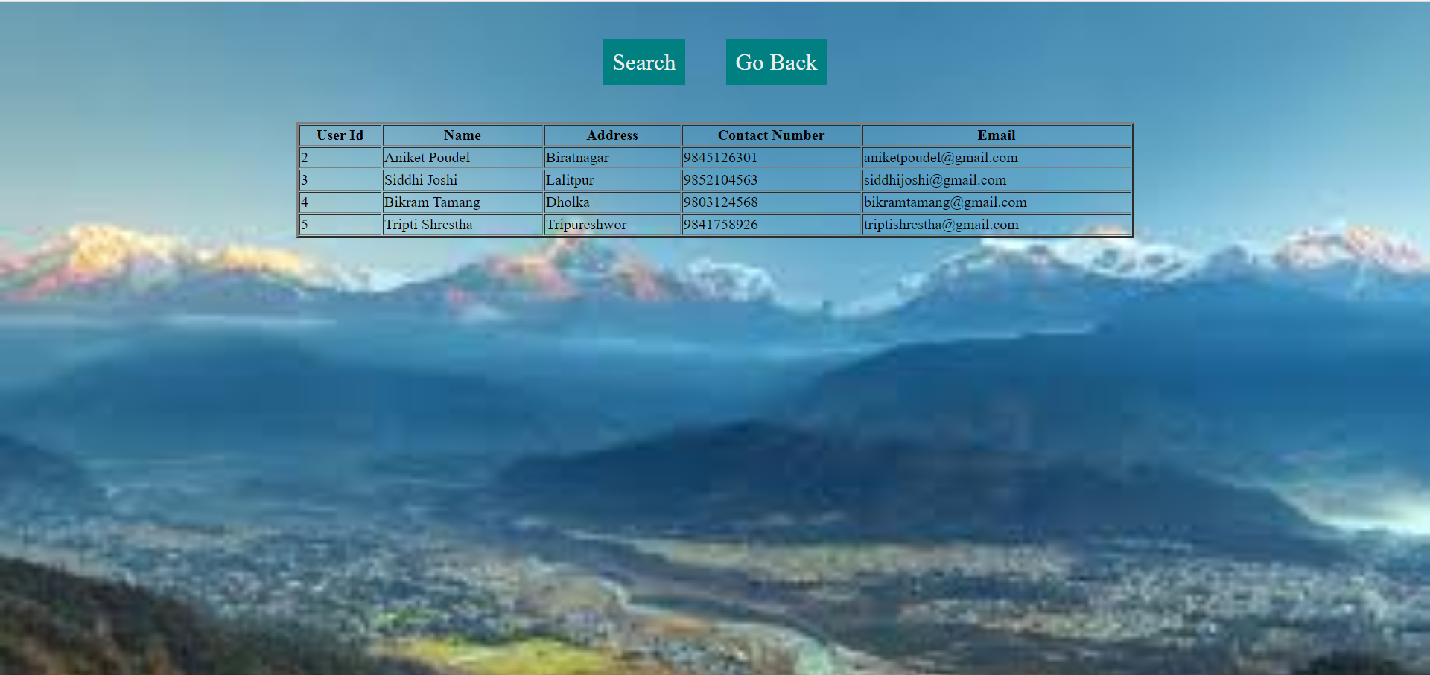

**Figure 3.2.5.4: List of Passengers after Deletion of a passenger**

# CHAPTER 4

# CONCLUSION

*The developed system is very easy to use and time saving. It maintains the records of various passengers and provide quick services to the passengers. The user can book the tickets for their trip by using this system. This system is useful to the people who loves travelling and exploring new places.*